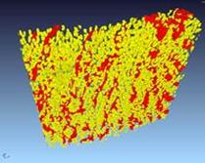

Computationally Intensive Imaging

USRG presents:

*''Godfrey Hounsfield: Intuitive Genius of Computed Tomography.''*

By **Richard Waltham (ex EMI - Central Research Labs)**

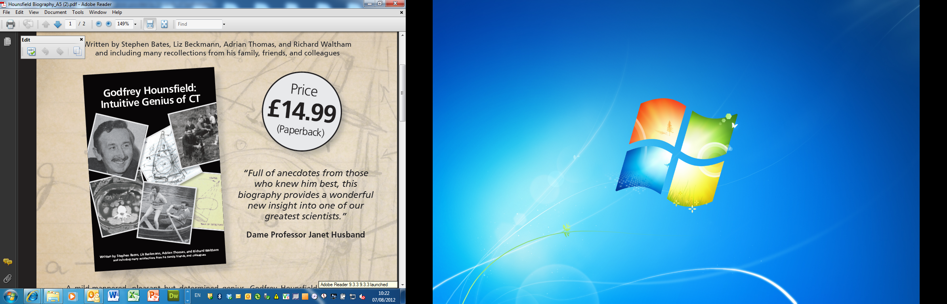

**Thursday 18th October 2012**

**16:00-17:00pm**

**Building 85 (Life Sciences Building), Room 2207**

**(Followed by drinks reception 17:00-18:00pm)**

To confirm your attendance at this event please go to: <http://www.southampton.ac.uk/~muvis/cii_hounsfield_form.html>

Godfrey Hounsfield: intuitive genius of CT

When Godfrey Hounsfield first spoke in public about clinical images from his prototype Computerised Tomography scanner on 20 April 1972 he launched the modern era in medical imaging and he gave a huge boost to the use of intensive computing. To mark 40 years since that pivotal year we will apply CT methods to reconstruct history from the available angles, including projecting film clips from the 1970s.

* What insight can that give us into the next breakthrough?
* What are the barriers?
* What is an intuitive genius?

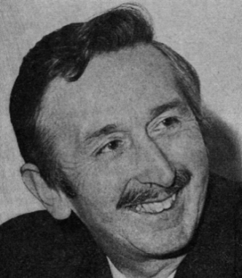

**Godfrey Hounsfield in 1972**  
(photograph copyright EMI Music)

Godfrey Hounsfield was pleasant and soft-spoken but in his own quiet way he was a man with a mission. Normal structures, rules and conventions seemed invisible to him. He was strongly driven by the vision of using science and engineering to improve the world for ordinary people. What captured his imagination was the possibility of making big breakthroughs: he wanted to make improvements of a factor of a hundred. He had little interest in making small optimisations to an existing technology. His path involved huge risks, but when it worked he changed the world. His biggest breakthrough was to prove to a remarkably sceptical world that CT could detect tumours and blood clots in the brain at acceptable cost and using acceptable X-ray dose. A quote from 1972 says: *‘Mr. Hounsfield has been the guiding expert throughout all aspects of the work. The EMI-scanner was as much a one-man invention as anything can be these days.’* Yet that man was thought by his father and his teachers to be intellectually retarded, he left school with no qualifications, and his pioneering work on CT scanning was done on a miniscule budget.

The facts about the funding of this pioneering work have only recently been made public. They broke the rules of business theory, but it took guts, vision and stubborn determination to reach the breakthrough.

# About the speaker:

Richard Waltham studied engineering at Bristol University, UK. He worked with Godfrey Hounsfield on CT scanners from 1973 onwards, joining his research team at the EMI company shortly after the pioneering work which launched practical CT scanning in hospitals. He is named as inventor on several patents. He is now retired, and he is an unpaid author of a new biography of Godfrey Hounsfield which is published by the Br. Inst. of R